User Manual

1. Title Page
- Solugen Version 1
- WOU360 LLC/Solusun LLC(Inactive)
- October 2024
- Solusun LLC/Kevin Crooks

2. Table of Contents
- Introduction
- Getting Started
- Product Overview
- Operating Instructions
- Troubleshooting
- Upgrading
- Technical Specification
- Support
- Appendices
- Revision History

3. Introduction
- What is Solugen – Solugen is a Software Development and DevSecOp productivity tool that is aimed at aiding each actor in the software development life-cycle and is targeted at the Django Framework. It is a tool designed to improve the efficiency of software generation, maintainability of software products, and developer understanding. Solugen is designed to allow development teams to design more and code less.
- Purpose of the Manual – This manual serves to provide instruction on the installation and usage of the Solugen Application.
- Intended Audience – This manual is intended mainly for IT Managers, Software Architects, Full-stack Developers and UX/UI developers. This application is also intended for developers, technical writers, database administrators, and software testers.
- Scope and Furure Versions– This documentation covers the first version of solugen which is a stand-alone command line application that generates Front-End code(HTML5, CSS3 and JavaScript) using XML generated from spreadsheet applications(Excel, LibreOffice Calc, Numbers). Version 1 is primarily intended for UX/UI designers, but can be used by all actors in the software development life-cycle. Version 2 is intended to cover all actors in the software development life-cycle and will be a stand-alone C++ desktop application. Future versions will include Back-End code generation, including database and server side scripting. Future versions will also incorporate documentation usage, documentation generation and login & security generation for the Django.

4. Getting Started

Software Requirement: The C++ compiler or higher and Microsoft Excel 2007 or higher is required for Solugen Version 1.

Environment: The present version requires Windows 10 or higher to operate.

Download and Setup: The repository of Solugen can be forked at the location https://github.com/kcrooks7/Solugen
The repository can be downloaded and compiled from the main file SoluGen.CPP or a compiled version can be downloaded from the location https://github.com/kcrooks7/Solugen/blob/main/Sgen.exe
Download Solugen/XMLSchema if not already downloaded.
Optional: See Code Documentation for detailed explanation of the Solugen codebase.

5. Product Overview

Product features:
Solugen currently allows a UX/UI designer or other team members to generate HTML5, CSS3 and JavaScript from XML files generated from design specifications inserted in specific Excel Templates.

Screenshots:
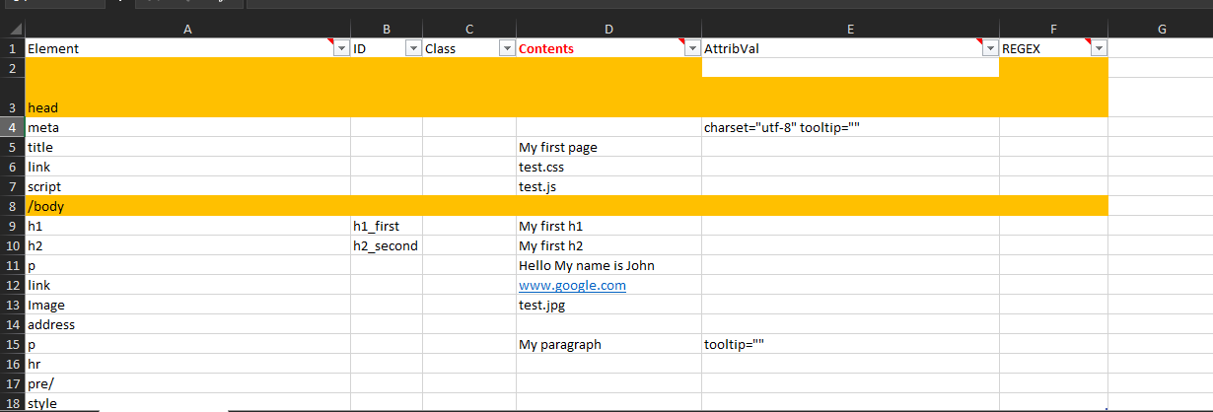
Screenshot 1: Excel Template for HTML5 genration

HTML_Schema.xml should be loaded in this section of the Excel Template for the generation of the final XML file. Knowledge of HTML5 is needed for this section. Each column should be populated with the expected HTML5 code for the specific row element.
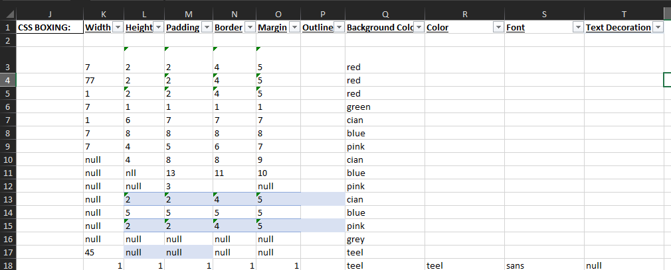
Screenshot 2: Excel Template for CSS3 generation

CSS_Box_Schema.xsd should be loaded in this section of the Excel Template for the generation of the final XML file. Knowledge of CSS3 is needed for this section. Each column should be populated with the expected CSS3 code for the specific row element.
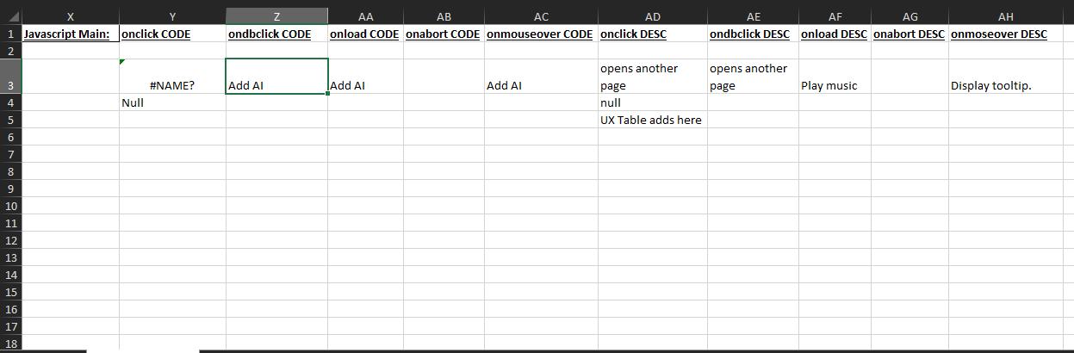
Screenshot 3: Excel Template for JavaScript generation

JS_MainEvent_Schema.xml should be loaded in this section of the Excel Template for the generation of the final XML file. Knowledge of JavaScript is needed for this section. Each column should be populated with the expected JavaScript code for the specific row element. The JavaScript code can be generated from an AI prompt tool such as Numerous.AI. The description of the JavaScript behavior can also be written in comments to be coded in later.

6. Operating Instructions
Directions:
1) Use Excel template to specify front-end design for HTML5, CSS3, and JavaScript.
2) Load the specific schema file for the specific template.
3) Generate XML file and store in a specific folder with desired name.
4) Copy and paste Sgen.exe or you compiled version into the folder that contains all the XML files.
5) Load EXE file.
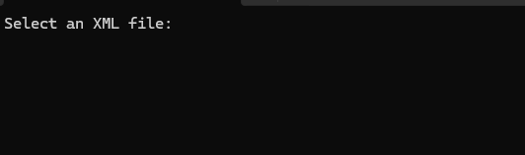

6) Enter the name of the file for which you intend to generate code.
7) Retrieve generated files from the location of your XML specification files.

Example:

7. Troubleshooting
If you have an issue with the application you may recompile using a C++ IDE. If issue persists, then email support with a bug report.

8. Upgrading
The tool is open-source, and updates will be made publicly available as soon as new features or improvements are completed.

9. Technical Specifications

10. Support
Email k.kevin7@gmail.com for assistance or report an issue on GitHub

11. Appendices

12. Revision History
- Version 1, October 2024, No Updates

